**Week 6: EFA Assignment**

**Thanmai Nallani**

**School of Professional Studies, Saint Louis University**

**Applied Analytics & Methods 2: Survey Approaches – 22(Fall 2024)**

**Professor: Anna E. Brown**

**Evaluating HR Job Applicants Using Exploratory Factor Analysis: A Comparative Approach**

**Introduction:**

The selection of talent is a critical activity for any company that seeks to recruit high performers. This study goes beyond the conventional methods of assessment by using sophisticated statistical approaches in the evaluation of job applications. The research makes use of exploratory factor analysis to unravel subtle insights into candidate potential, underpinning the psychological and professional variables that support the thorough assessment of candidates. The following methodology offers human resources professionals an effective framework for evaluation in making data-driven hiring decisions by examining several analytical techniques, including raw scoring, orthogonal, and oblique factor analyses.

**Purpose:**

This study is aimed at developing a more in-depth and sophisticated method of evaluating candidates beyond conventional numerical ranking techniques. To identify the complex psychological and professional factors that actually distinguish outstanding job seekers, the study will use advanced statistical methods such as exploratory factor analysis.

**Objective:**

One of the major goals of this study is to develop a comprehensive and multi-dimensional approach to candidate evaluation that systematically examines the various variables affecting a job candidate's potential. It intends to identify, through the use of sophisticated statistical methods involving the exploration factor analysis, the psychological and professional factors that distinguish high performers. The aims are to critically review and validate current recruitment assessment practices and develop a more comprehensive framework for talent selection. It also aims to go beyond conventional linear ranking systems by offering a sophisticated, data-driven technique that gives deeper insight into the quality of candidates, the dependability of the standards of evaluation, and the complex nature of professional greatness.

**Research Questions:**

1. How consistent are the rankings produced by the three different methods of analysis-raw summed scores, orthogonal factor analysis, and oblique factor analysis-and what do these various analyses have to say about the basic concepts underlying the assessment of candidates?

2. Due to the negative reliability on the fourth component, determine the validity and reliability of the four factors—motivation, professional qualities, interpersonal attributes, commitment/academic strength—in assessing job candidates.

3. How much do the variables Academic Ability and Keenness to Join form a cohesive construct, and how can these variables be adjusted to increase the reliability of the fourth component in future candidate assessments?

**Factor Analysis Results:**

The scree plot for the image obviously levels out after the fourth element, indicating that four factors should be retained for further analysis. That the eigenvalues drop below 1 after the fourth factor, which explains 82% of the variance, substantiates this. The plot displays a simple method to determine how many components should be extracted from the data.

**Orthogonal Factor Analysis**

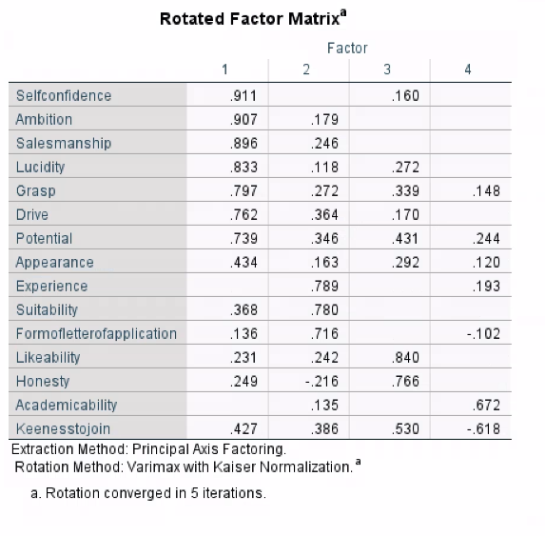

Using exploratory factor analysis with Varimax rotation, four interpretable factors out of 12 job application qualities were extracted. Factor 1, "Health Motivation," includes self-assurance, ambition, sales prowess, clarity, desire, grasp, and potential. Factor 2, "Professional Suitability," includes experience, suitability, and quality of the application form. "Interpersonal Skills," or factor 3, includes likeability and honesty. In Factor 4, "Academic and Motivational Attributes," academic aptitude and eagerness to participate are included. All factors have sufficient reliability, according to reliability estimations, with Factor 1 having the highest dependability, followed by Factors 2, 4, and 3.

**Oblique Factor Analysis**

A factor analysis using Direct Oblimin rotation was conducted on the 12 items to compare the results of orthogonal rotation. The factor structure might still be interpreted by and large: Academic ability and eagerness to join had been included in Factor 4 ("Academic and Motivational Attributes"), while Factor 1 ("Health Motivation") now included self-confidence, ambition, salesmanship, lucidity, drive, grasp, and potential; Factor 2 ("Professional Suitability") now included suitability, application form quality, and experience; while likeability and honesty have included in Factor 3 ("Interpersonal Skills"). All the variables were reliable; however, the reliability estimates had Factor 1 as the most dependable. The three best applicants as determined by summing their academic aptitude and eagerness to join matched those chosen based on raw and orthogonal scores.

Cronbach’s Alpha for Each Factor Found Using Exploratory Factor Analysis (Oblique)

Top Three Candidate Scores by Raw Summed Score, Orthogonal Score, and Oblique Score

**Conclusion:**

Firstly, it seems that these three candidates are securely high performers irrespective of the scoring system since they have emerged in raw summed scores as well as orthogonal and oblique factor analyses constantly. Secondly, exploratory factor analyses extracted four significant components that gave a deeper insight into the underlying constructions measured. These were commitment/academic strength, professional credentials, motivation, and interpersonal qualities. For better measurement, the low dependability of the fourth factor indicates that its variables need to be changed or replaced. Furthermore, the somewhat higher sensitivity of the oblique factor analysis suggests possible interdependencies between the constructs, making this rotation method better for next evaluations. Overall, this study has showcased how advantageous advanced statistical techniques are in the provision of full insight into candidate potential for HR-related roles.

**Summary:**

The study, using raw summed scores, orthogonal factor analysis, and oblique factor analysis, among other techniques, attempted to identify the best candidates for the job. Findings across these many methodologies consistently identified the top three candidates, thus suggesting that they were reliable high performers.

The factor analyses identified four important components that gave greater meaning to the underlying conceptions assessed: academic strength, commitment, professional credentials, and motivation. The fourth factor, however, demonstrated poor reliability, raising a red flag regarding problems with the component variables that need attention.

While the orthogonal approach did not differ much, the oblique approach showed a relatively higher sensitivity; this could have been because of inter-construct dependence. All things said and done, this study depicts how such advanced statistical methods can yield comprehensive and critical evaluation.

**Recommendations:**

**Also Consider the Fourth Factor:** The low reliability of this factor suggests that the variables Keenness to Join and Academic Ability are not good measures of a consistent construct. This component should be of high priority to revise or replace these factors in order to have a valid and reliable component for future candidate assessments.

**Expansion of the Assessment Framework:** While the current study found four underlying dimensions driving candidate evaluations, additional construction may be important for optimal performance in HR-related jobs.

**References:**

1.Saint Louis University. (2024). Week 6 statistical software resources and tutorials: AA 5222-22, Applied Analytics. Canvas: Mediation analysis using PROCESS [PDF].

<https://canvas.slu.edu/login>

2.Hatcher, L. (2013). *A step-by-step approach to using SAS for factor analysis and structural equation modeling* (2nd ed.). SAS Institute.

3.Field, A. (2018). *Discovering statistics using IBM SPSS statistics* (5th ed.). Sage Publications.